Surge Sportstech BLE SDK iOS Software Design Document

Version 1.0


Tismo Technology Solutions (P) Ltd.
22/2, Palmgrove Road
Bangalore 560047, INDIA
Confidential
This document contains confidential information of Tismo. In consideration of receipt of this document, the recipient agrees to maintain such information in confidence and to not reproduce or otherwise disclose this information to any person outside the group directly responsible and authorized to use its contents, except that there is no obligation to maintain the confidentiality of any information which was known to the recipient prior to receipt of such information from Tismo, or becomes publicly known through no fault of recipient, or is received without obligation of confidentiality from a third party.

Table of Contents
Table of Contents 2
1 Design Overview 5
1.1 Introduction 5
1.2 References 5
1.3 Design Considerations and Constraints 5
1.4 Hardware and Software Platform 5
1.5 System Architecture 6
1.6 Modules & Interfaces 6
2 Detailed Design 9
2.1 class SWBLEManager 9
2.1.1 Functional Description 9
2.1.2 Local Data & Interfaces 9
2.2 protocol SWManagerDelegate 13
2.2.1 Functional Description 13
2.2.2 Local Data & Interfaces 13
2.3 class SWDevice 15
2.3.1 Functional Description 15
2.3.2 Local Data & Interfaces 15
2.4 protocol SWDeviceDelegate 18
2.4.1 Functional Description 18
2.4.2 Local Data & Interfaces 19
2.5 class AcquisitionData 20
2.5.1 Functional Description 20
2.5.2 Local Data & Interfaces 20
2.6 Helpers 20
2.6.1 enum BLEState 20
2.6.2 enum SWDeviceState 21
2.6.3 enum SWDeviceType 22
2.6.4 enum SWConfiguration 22
2.6.5 enum SWBatteryStatus 23
3 Third party tools / libraries used 24
4 Issues 25
5 Additional Design Notes 26

Revision History
Version Number | Date | Changes | Author | Reviewed By | Approved By
1.0 | 14-Dec-21 | Initial Version | Developer | Zubair K | Zubair K

Design Overview

Introduction

Surge Sportstech is designing a smart weight system that includes a pair of dumbbell, a kettle-bell and a dock. It is equipped with sensors for tracking the movements while user is performing exercise. This data is handed across to the mobile application via a Bluetooth Low Energy module where the data will be processed to send feedback to the user. The aim of this project is to develop an iOS SDK that can be used to communicate with the smart weight utilizing iOS’s BLE technology.

References
- Tismo’s proposal to Surge Sportstech - ”Tismo_SurgeSportstech_Smartweight BLE SDK_Quote.pdf”
- BLE_command_interface_document.docx

Design Considerations and Constraints
- The sdk shall be scalable for future development
- The sdk should be designed to support multiple devices
- The sdk should be easy to integrate
- The sdk will not remember previously connected devices on reopening of application.
- The sdk will not set any connection limitations for the devices.

Hardware and Software Platform
Items | Details
Target Operating System | iOS version 13 and above
Operating system for development | Mac OS 11.3
Development language | Swift
Framework | SwiftUI
IDE | XCode Version 12
Configuration Management tool | GIT
Web based Defect Tracker | Redmine
Task Management | Redmine

System Architecture
The basic architecture for the SDK can be defined in the following way:

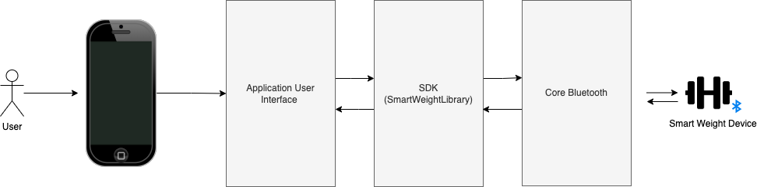
Figure 1 : Basic Communication Flow Diagram

The Smartweightlibrary acts as an interface between the application layer and Core Bluetooth of the underlying iOS. It implements all of the necessary functions required for discovery, connection and communication with the smart weight device.Core Bluetooth on the other hand will directly communicates with the device and deliver the data it sends in raw format to the SDK.
The Smartweightlibrary filters out the Smart Weight BLE devices from pool of BLE devices and notify the application when it discovers one . The application can easily connect and communicate with the device using simple calls to the library. The library keeps track of all the smart weight devices that are once connected. It handles conversion of raw data to the required format so that application can present it to the user without doing any computations.

Modules & Interfaces

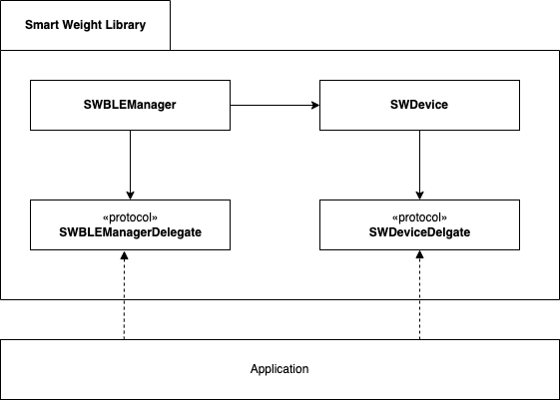

The major components of the Smart Weight Library is the SWBLEManager , SWDevice and their associated delegates SWBLEManagerDelegate and SWDeviceDelegate.
- SWBLEManager
- Handles BLE state of the application
- Manages discovery cycle
- Maintain all the smart weight devices
- SWBLEManagerDelegate
- Notifies app on update of BLE state
- Informs app on connection state change of the device
- SWDevice
- Manages peripheral communication
- Parsing raw data retrieved from the device
- Writing required commands
- Provide all the configuration details of the device
- SWDeviceDelegate
- Notifies app on receiving the sensor data
- Informs app on connection state change of the device
- Notifies the app if the device's battery status changes.

Detailed Design

class SWBLEManager

Functional Description
SWBLEManger is public class that manages Bluetooth communication with the underlying iOS system. This class handles monitoring the Bluetooth state of the device, scanning for smart weight devices, and connecting to and disconnecting from them.When initialized, SWBLEManager, the intended delegate are required to be included to receive the asynchronous method calls of the SWBLEManagerDelegate protocol.

iOS has built-in prompts that will appear to notify the user that an app requires Bluetooth and to request access, and as is the case with most of iOS’s system-level prompts and permission settings, the app has essentially no control. The prompts will come in role on the first initialization of SWBLEManager. If a user denies your app Bluetooth access, the app will receive a BLEState of .unauthorized, at which point it’s up to the application to offer user some kind of directive to enable Bluetooth permissions through app’s page in Settings. The same goes for directing a user who has disabled Bluetooth

Local Data & Interfaces

- isScanning:Bool
Returns scanning status of the device - true/false

- bluetoothState:BLEState
The state of Bluetooth

- startScan()
Discussion:
Initiate scanning for smart weight devices.
The didStartScan() delegate method will be called once the initiation is successful. Note that the scanning will begin only when the Bluetooth is turned on. The smart weight devices are filtered from the rest of the BLE devices based on the advertised service id. Once a smart weight device is discovered, it will return the device via didDiscover(device:SWDevice) delegate method. The scanning will be automatically stopped after 10 seconds.

- startScan(timeInterval:TimeInterval)
Starts scan with the specified time interval
Parameters:
timeInterval:TimeInterval - time interval

- stopScan()
Will stop scanning for smart weight devices; The didStopScan() delegate method will be called once the scanning is stopped.
Note: The scanning process will be automatically stopped when
- The time interval of scanning is completed
- When Bluetooth is turned off between scanning process
In both the cases didStopScan() delegate method will be called

- connect(device:SWDevice)
Discussion:
This function initiates the device's connection procedure. If the device is connecting for the first time, the state will be updated to '.connecting'; otherwise, the state will be '.reconnecting'. If the device is successfully connected, the 'didUpdateConnectionState' delegate method is called, with the connection state set to '.connected'.
The SDK will begin to observe the device once it is connected. So if the app wants to discover the device again, you may need to remove() it first and then try to discover.
Note:
- The connection will be initiated only when Bluetooth is turned on
- During connection process, if device fails to discover services or characteristics - it will be automatically disconnected.

Parameters:
device:SWDevice - SWDevice that requires a connection

- connect(devices:[SWDevice])
Discussion:
This function will initiate connection with set of smart weight devices

Parameters:
devices:[SWDevice] - Set of SWDevice(s) that require connection

- disconnect(device:SWDevice)
Discussion:
This method will initiate disconnection process. On successful disconnection, will call didUpdateConnectionState delegate method with connection state as .disconnected
Note: All the connected devices at the instance of ‘Bluetooth turn off’ will be reconnected on ‘Bluetooth turn on’

Parameters:
device:SWDevice - SWDevice that requires a disconnection

- disconnect(devices:[SWDevice])
Discussion:
Initiate disconnection for set of device
Note: Sdk will try to reconnect to the device indefinitely in case of unexpected disconnection: eg - there is no battery left,user turned off the device without disconnecting,when the device is gone out of range after connection

Parameters:
devices:[SWDevice] - Set of SWDevice(s) that require disconnection

- getObservedDevices()->[SWDevice]
Will return all the observed devices. A device will be added to observed devices when it is connects for the first time after the opening of application

- getConnectedDevices()->[SWDevice]
Returns all devices that are connected at the instance.

- getDiscoveredDevices()->[SWDevice]
Returns all discovered devices

- remove(device:SWDevice)
Discussion:
Upon invocation, will remove all the reference associated with the device.Removal of device results in auto disconnection without notifying through delegates. It is strongly recommended to deallocate all the objects associated with the device before removing

Parameters:
device:SWDevice - SWDevice that needs to be removed

- retrieveDevicesWithIdentfier(identifiers:[UUID]) ->[SWDevice]
Discussion:
Will retrieve the smart devices based on the identifier.
Useful when the app needs to retrieve previously connected smart weight devices

Parameters:
identifiers: [UUID] - Identifiers of SWDevice that needs to be retrieved
setDelegate(delegate:SWBLEManagerDelegate?)
Will update the delegate property to the specified delegate
Parameters:
1. delegate:SWBLEManagerDelegate?
SWBLEManagerDelegate object that needs to be updated.

protocol SWManagerDelegate

Functional Description
SWBLEManagerDelegate is a protocol defined by SDK to notify the app on event of scanning, discovering device, BLE state changes, connection or disconnection

Local Data & Interfaces

- swBleManager(didUpdateBLEState state:BLEState)
Discussion:
This method is invoked whenever state of Bluetooth is updated. Under normal circumstances, this method will be called almost immediately after initializing the swBleManager, with the included state being .poweredOn. The commands should be issued only when the state is powered on. Else all the commands will become invalid and will have no effect

Parameters:
state:BLEState - state of Bluetooth of the phone or application

- optional swBleManager(didStartScan isScanning:Bool)
Discussion:
This method is called whenever the app starts to scan for the smart weight device.

Parameters:
isScanning:Bool - indicate whether app is currently scanning

- optional swBleManager(didStopScan isScanning:Bool)

Discussion:
This method will be called whenever the app stops scanning after the specified time interval, or when ble is turned off while scanning, or when the user requests to stop scan.

Parameters:
isScanning:Bool - indicates whether the app is currently scanning

- optional swBlemanager(didDiscover device:SWDevice)
Discussion:
This method will be called whenever a smart weight device is discovered.

Parameters:
device:SWDevice - The smart weight device which is discovered

- optional swBleManager(didUpdateConnectionState device;SWDevice, connectionState:SWDeviceState)
Discussion:
Any change in connection state of a smart weight device will result in calling this method.

Parameters:
device:SWDevice - The smart weight device of which the connection state has been updated.
connectionState:SWDeviceState - Indicates the current connection state of the device

class SWDevice

Functional Description
SWDevice is a public class that directly communicates with the smart-weight device. It stores all information of the smart weight device including its name, weight and other configurations. It is responsible for retrieving data from the device, parsing it into necessary format and sending it to the application. This class handles monitoring connection state of the device, as well as connecting, disconnecting and acquiring sensor data from the device. You’ll need to set the intended delegate to receive the asynchronous method calls of the SWDeviceDelegate protocol.

Local Data & Interfaces

- delegate: SWDeviceDelegate?
Delegate through which callbacks are invoked

- type:SWDeviceType
Returns the type of the device dumbell/kettlebell/dock

- name:String
Name of the smart weight device that is advertised

- identifier:UUID
System generated unique identifier of the device.

Apple does not allow to retrieve mac address of the device. Instead, Apple assigns a unique UUID that’s meaningless outside of the app’s context, but that can be used to retrieve and initiate a connection to that particular device.

- connectionState:SWDeviceState
The connection state of the device

- firmwareVersion:Int
Firmware version of the smartweight device

- hardwareVersion:Int
Hardware version of smart weight device

- weight:Int
The configured weight of the device

- batterystatus:BatteryStatus
The batteryStatus of the device: high/medium/low

- configuration:SWConfiguration
The configuration of the device -left/right/na. Applicable only for dumbbell.

- connect()
Discussion
Initiate connection with the device. If connection is sucessfull, it will result in calling of didUpdateConnectionState delegate method of both SWDeviceDelegate and SWBLEManagerDelegate with connection state as .connected

Note: Changes in connection state will result in calls to didUpdateConnectionState delegate method of both SWDeviceDelegate and SWBLEManagerDelegate. The application can make use of these delegate methods to track the change in connection state according to the convenience.

- disconnect()
Discussion
Issue disconnection from the device. Upon disconnection, will result in calling of didUpdateConnectionState delegate method with connection state as .disconnected

- readBatteryStatus()
Discussion
It will issue a read battery status command to the device. Upon receiving a response from the device, this will result in a call of the didUpdateBatteryStatus delegate method.

- startAcquisition()
Discussion
This method will initiate acquisition of sensor data from the device. The device will continue to notify the data until the app explicitly stop the acquisition.
The didReceiveAcquistionData delegate method will be called every time the device notifies the data.

- stopAcquisition()
Discussion
This method will send a stop acquisition command to the device. The device will stop the acquisition of sensor data upon receiving the command.

- setRTC()
Discussion
On invoking this method, the current time-stamp will be synced with existing clock of the device

- setRTC(hour:Int,min:Int,sec:Int,ms:Int)
Discussion
On invoking this method, the given time-stamp will be synced with existing clock of the device.

Parameters
hour:Int - hour to be set
min:Int - minute to be set
sec:Int - second to be set
ms:Int - millisecond to be set

protocol SWDeviceDelegate

Functional Description
SWDeviceDelegate is a protocol defined by the SDK to notify the app when the connection state changes, the battery status is updated, sensor data is received, and so on.

Local Data & Interfaces
- swDevice(didUpdateConnectionState state:SWDeviceState)

Discussion
Invoked upon connection state change.

Parameters:
state: connection state of the device

- swDevice(didUpdateBatteryStatus batteryStatus:BatteryStatus, timestamp:TimeStamp)

Discussion
Invoked when battery status of the device is updated. The device will notify the SDK whenever the battery status is updated. SDK further will notify the application

Parameters:
batteryStatus: battery status of the device

timeStamp : Timestamp upon which the updated battery status

- swDevice(didReceiveAcquisitionData acquisitionData:AcquistionData, timestamp:TimeStamp)

Discussion
Invoked upon receiving acquisition data from the device.

Parameters:
acquisitionData: Acquisition data received
timeStamp : Timestamp upon which the data is received

class AcquisitionData

Functional Description
This class is defined to store the sensor data obtained during acquisition.

Local Data & Interfaces
- accelerometer:[(x:Double,y:Double,z:Double)]
Set of accelerometer sensor values

- gyrometer:[(x:Double,y:Double,z:Double)]
x,y,z coordinate values of gyrometer sensor

- magnetometer:[(x:Double,y:Double,z:Double)]
x,y,z coordinate values of magnetometer sensor

- init()
Initializes with empty data

- init(acceleroData:[Double,Double,Double)],gyroData:[(Double,Double,Double)],magnetoData:[(Double,Double,Double)])
Initializes data with specified values

Helpers

enum BLEState
Used to track the Bluetooth state of phone and application

.unauthorised
Indicates that the application is not authorized to use the Bluetooth Low Energy role.

.powered_off
Indicates that Bluetooth of the phone is currently powered off.

.powered_on
Indicates that Bluetooth of the phone is currently powered on and available to use.

.unsupported
Indicates that the platform doesn't support the Bluetooth Low Energy

.unknown
Unknown state,Updated imminent

enum SWDeviceState
Used to tracks the connection status of the device.

.discovered
State when application discovers the device. The initial state of the device will always be .discovered.

.connecting
State of the device when application attempts to connect for the first time

.connected
State of the device when it is currently connected

.disconnected
State of the device when it is currently disconnected

.reconnecting
State of the device when the application attempts to reconnect . Any attempt to connect following a disconnection will be considered as a 'reconnecting' state

enum SWDeviceType

.DUMBBELL
Indicate that discovered device is dumbbell

.KETTLEBELL
Indicate that discovered device is kettle-bell

.DOCK
Indicate that discovered device is dock

enum SWConfiguration
.left
The left configured position of dumbbell

.right
The right configured position of dumbbell

.na
Configuration positions are not applicable for kettle-bell and dock

enum SWBatteryStatus
.high
When voltage is in higher range - 0xff

.medium
When Voltage is in medium range- 0x7f

.low
When voltage is in lower range - 0x0a

Third party tools / libraries used
NA

Issues

Issue No | Description | Owner

List out the issues that have not been resolved during the design stage. Also list out the persons who are responsible for resolving the issue.

Additional Design Notes

  - Initial Setup

Permission
Starting iOS 13, it’s mandatory for developers to specify the Privacy Usage Description for Bluetooth by including NSBluetoothAlwaysUsageDescription in their info.plist file. Accessing Bluetooth without the usage descriptions would lead to a runtime crash.
For backward support for older iOS versions, NSBluetoothPeripheralUsageDescription needs to be defined as well

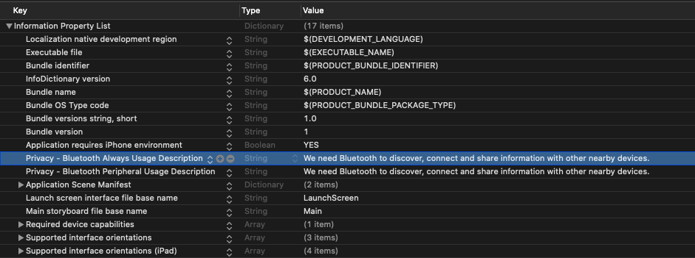

Importing Library
To import SmartWeightLibrary, drag and drop the library into the xcode project or workshop. Add the Frameworks, Libraries and Embedded Contents section in the app targets general pane.



